

Group Project

IMPLEMENTATION OF PICK AND PLACE USING THE MAGICIAN LITE ROBOT ARM

Team Members:

FREDERIC LI SIM YAM
KAUSHIK IYER CHANDRASEKARAN ANANTHANARAYANAN
KAIXIN ZHU
MD FOYSAL JOY
SPARSH RAJ

Course: MSc Robotics and Artificial Intelligence
Module Name: Kinematics and Dynamics of Industrial Robot Arms
Module Code: EG554V

Submitted to: Prof. Andres San Millan Rodriguez
Date of Submission: 20th Mar,2026
Abstract

This report describes the implementation of a pick-and-place using DOBOT Magician Lite robot arm. We study stacking operation of three blocks using the basic concepts of robot kinematics, workspace constraints and rudimentary considerations on dynamics. The target was specified in cartesian space, and an internal inverse kinematics solver was used to calculate the corresponding joint angles. Stability and collision-free operation was achieved using trajectory planning, workspace testing and timed delays. The results show successful performance of the task but also outline limitations of open-loop control, calling for sensor-based feedback enabling more scalable automation.

Contents
- Introduction 3

2 Material and Methods
2.1Task Design………………………………………………………………………………………………………….3
2.2Inverse Kinematics…………………………………………………………………………………………………3
2.3 Workspace and Trajectory Planning…………………………………………………..9
2.4 Dynamic Considerations……………………………………………………………...10
2.5 Comparison………… ………………………………………………………………..10

3. Result……………………………………………………………………………………………….11

4. Discussion……………………………………………………………………………………11

7. Conclusion………………………………………………………………………………….11

Introduction
Robotic arms are used extensively in industrial and research settings for tasks where precision, repeatability, and safety are paramount. They are typically used in logistics, electronics assembly, laboratory automation, automotive manufacturing, healthcare, construction and agriculture. According to the document, robotic manipulators are used for “precise insertion of components during assembly” and “handling hazardous chemicals”.
The first three joints of the DOBOT Magician Lite is in a revolute–revolute–revolute (RRR) structure, which makes it an articulated robot. Articulated robots have advantages like high workspace efficiency and high dexterity, but there are also challenges like non-uniform precision and dynamic coupling.]
The document includes a comparison of articulated robots versus Cartesian, cylindrical, spherical, and SCARA configurations which noted benefits [14] included “multiple inverse kinematics solutions” while drawbacks [15] emphasized “kinematic
.

2. Materials and Methods

2.1 Task Design

The pick-and-place process was described wholly in Cartesian coordinates. Another set of sequences demonstrated a robot was instructed to move to pick location, close gripper, move to placement location and release block. Specifically, the first pick point was specified as “(x=320, y=20, z=-15, r=0)” with an indication that a 0.5-second delay should be introduced before gripping.
This process was repeated for three blocks located at:
(320, 20, –15)
(320, –20, –15)
(300, –100, –15)
At the destination x–y coordinate, all blocks were stacked and z was varied to prevent collisions.

2.2 Inverse Kinematics
Instead of manually computing joint angles, the robot’s built-in inverse kinematics solver was used. The team “defined the goal position in 3D space” and allowed the controller to compute the required joint rotations.

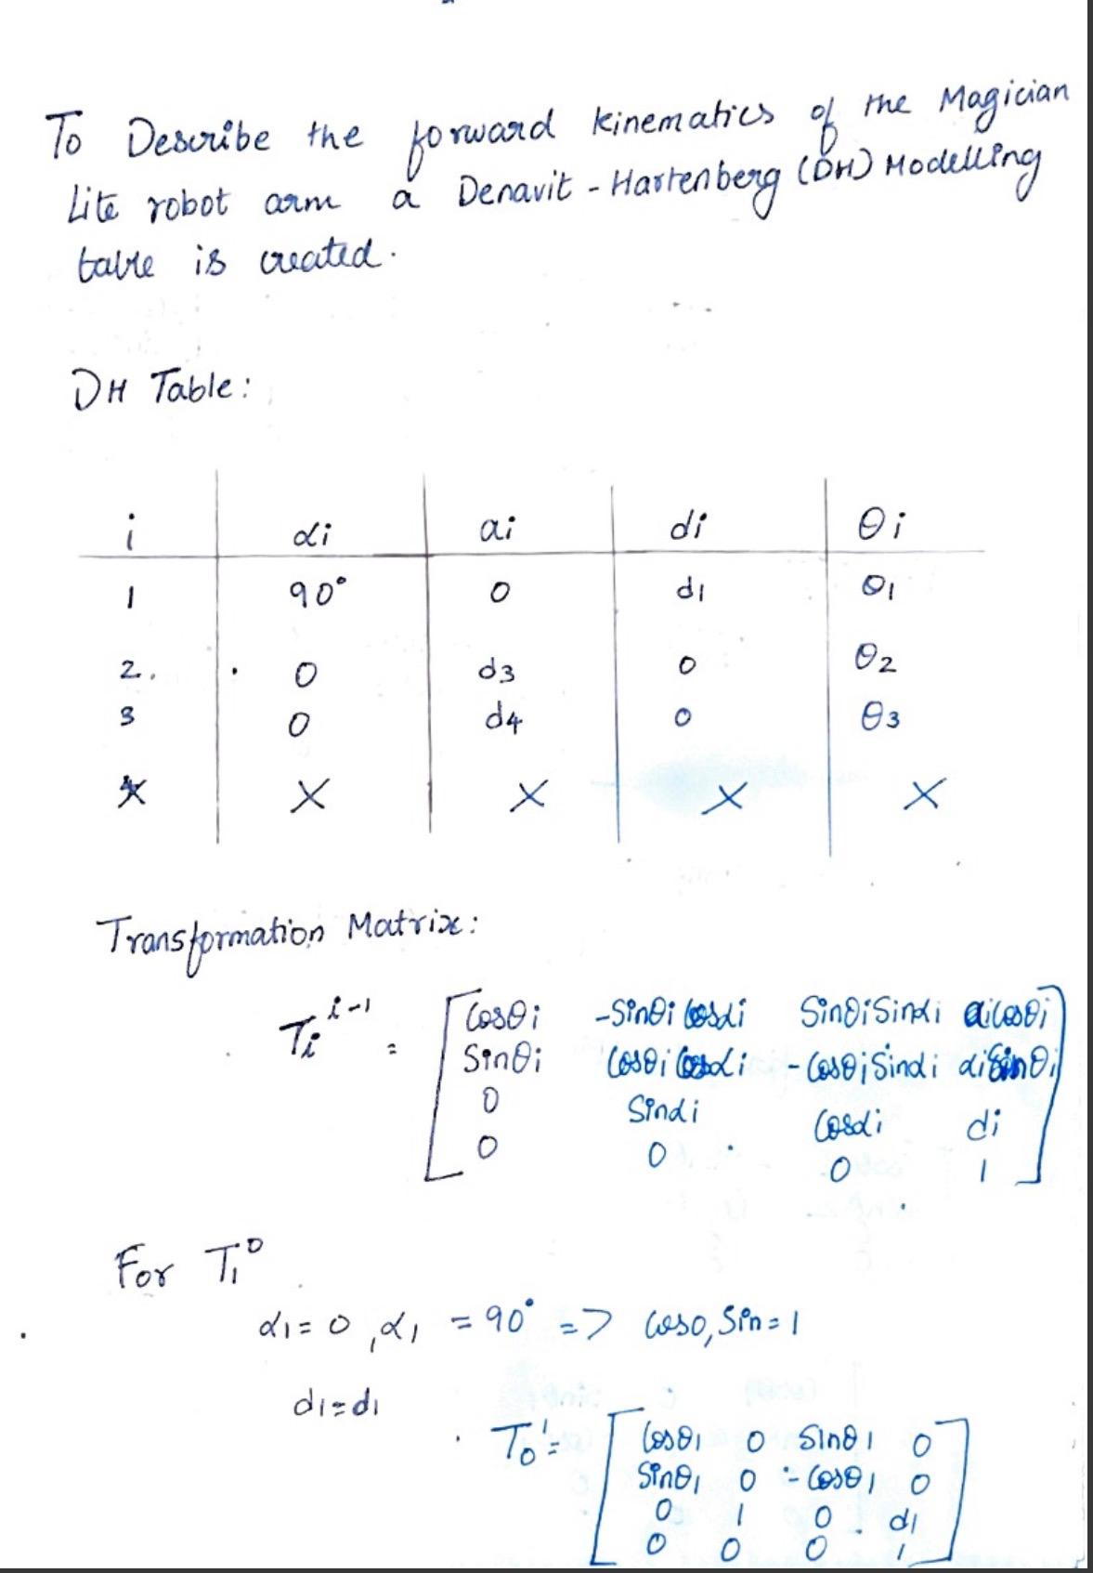

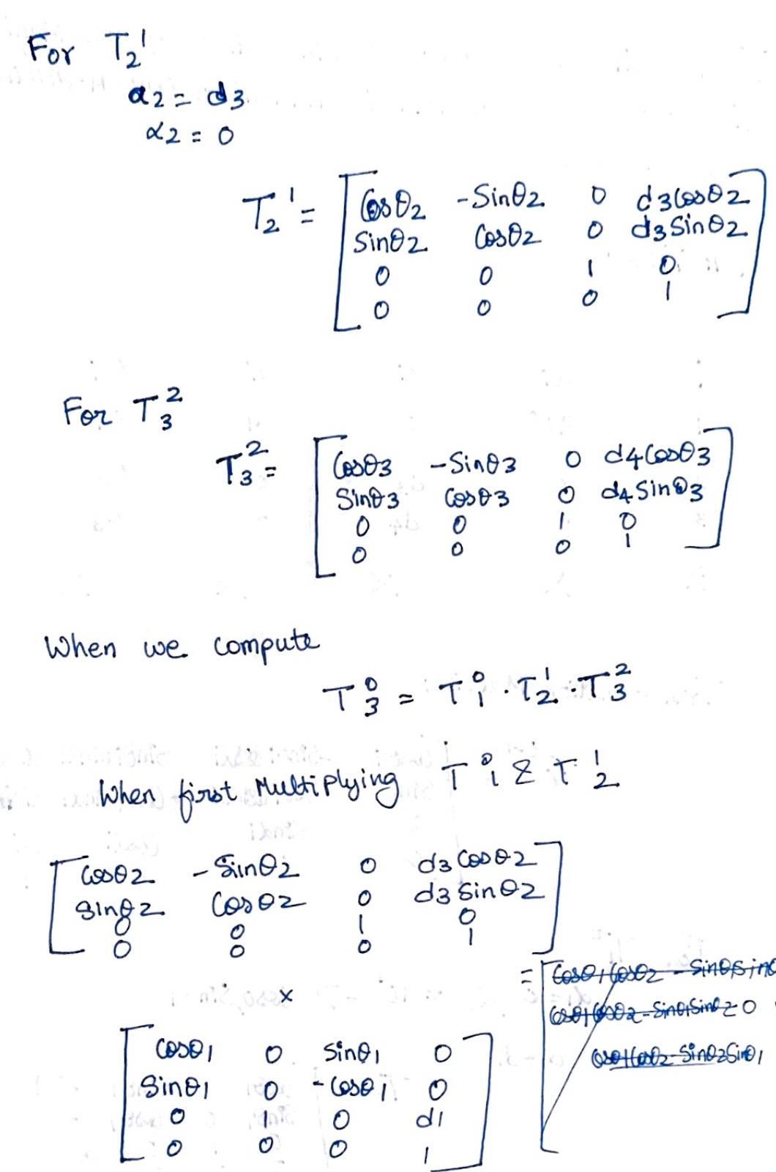

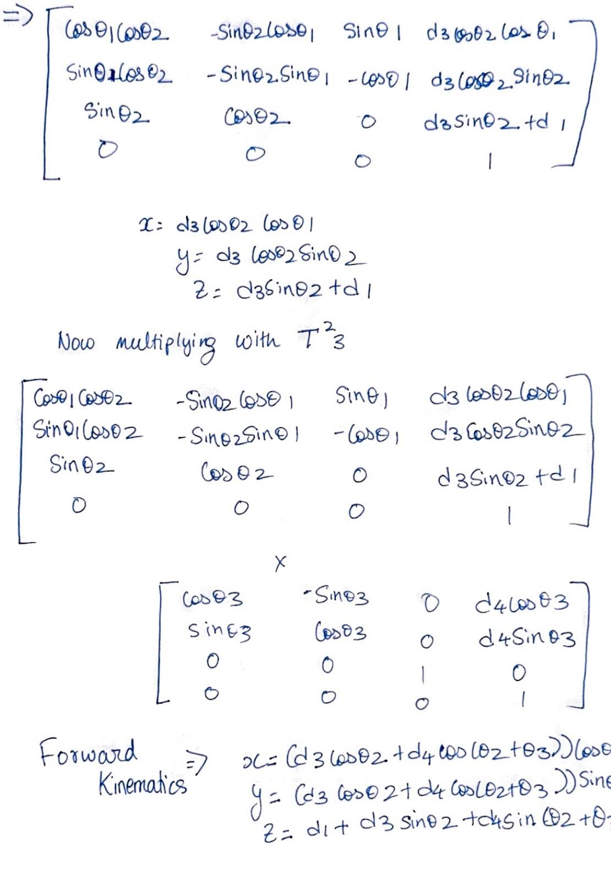

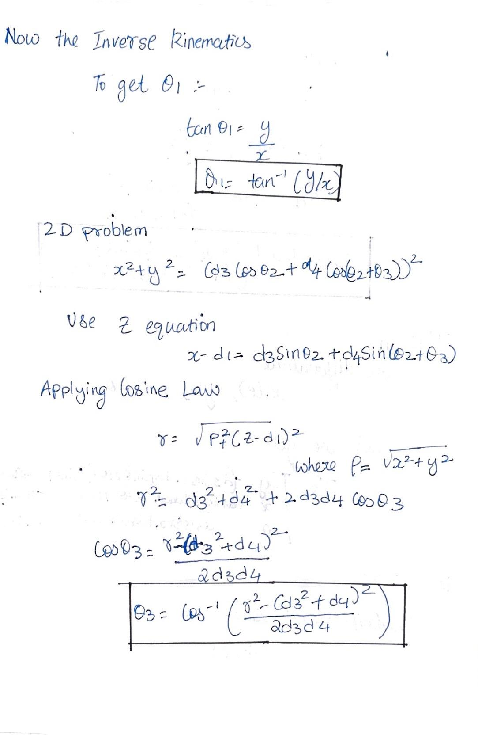

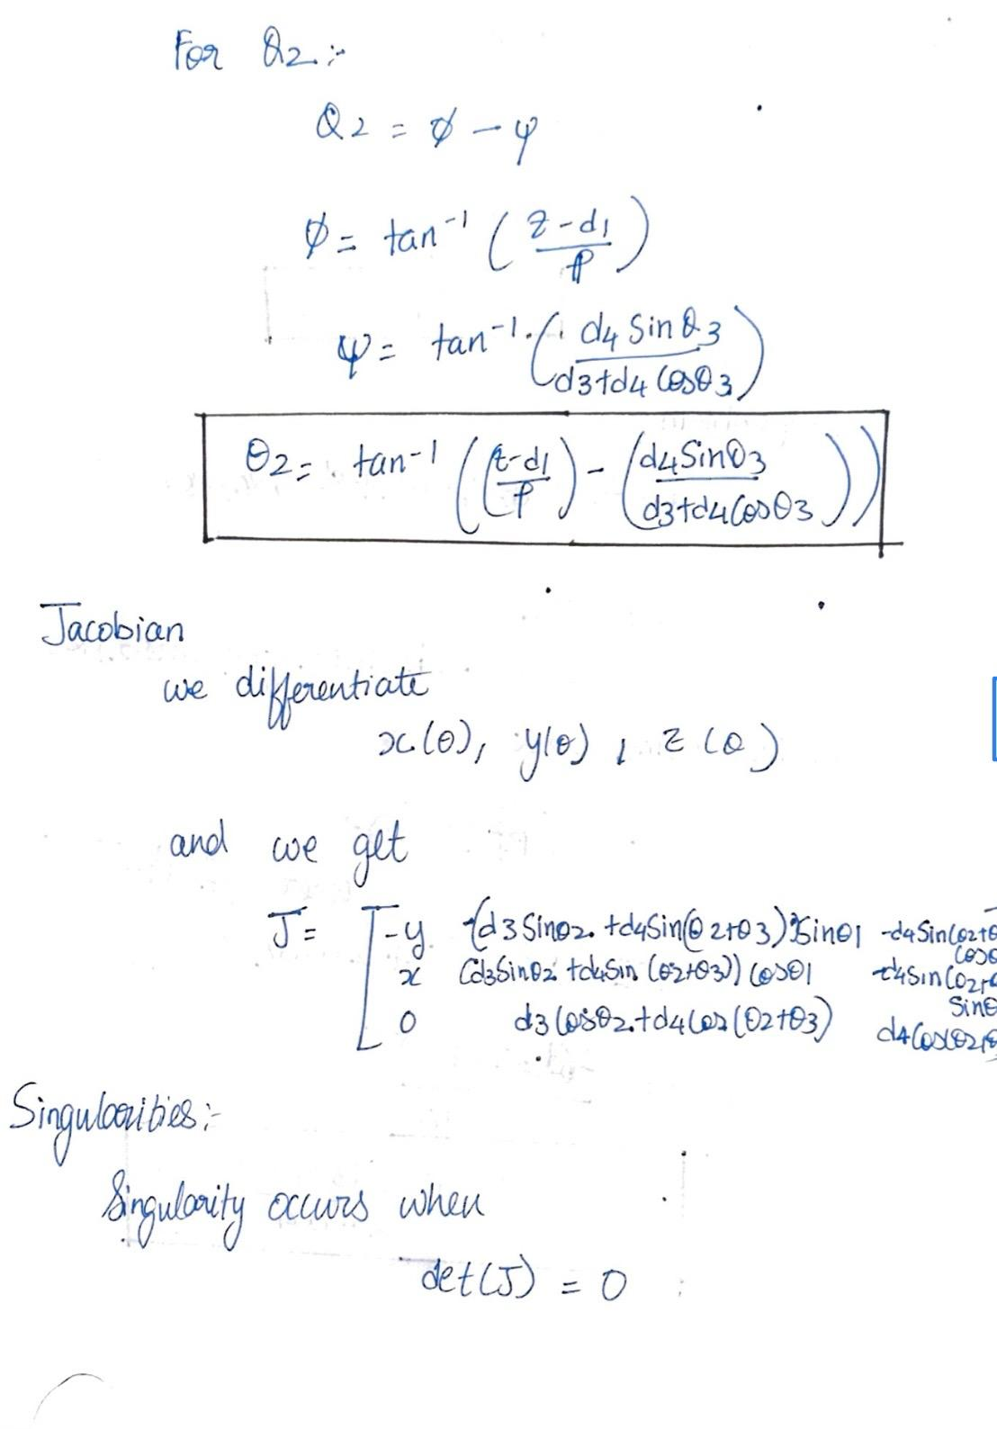

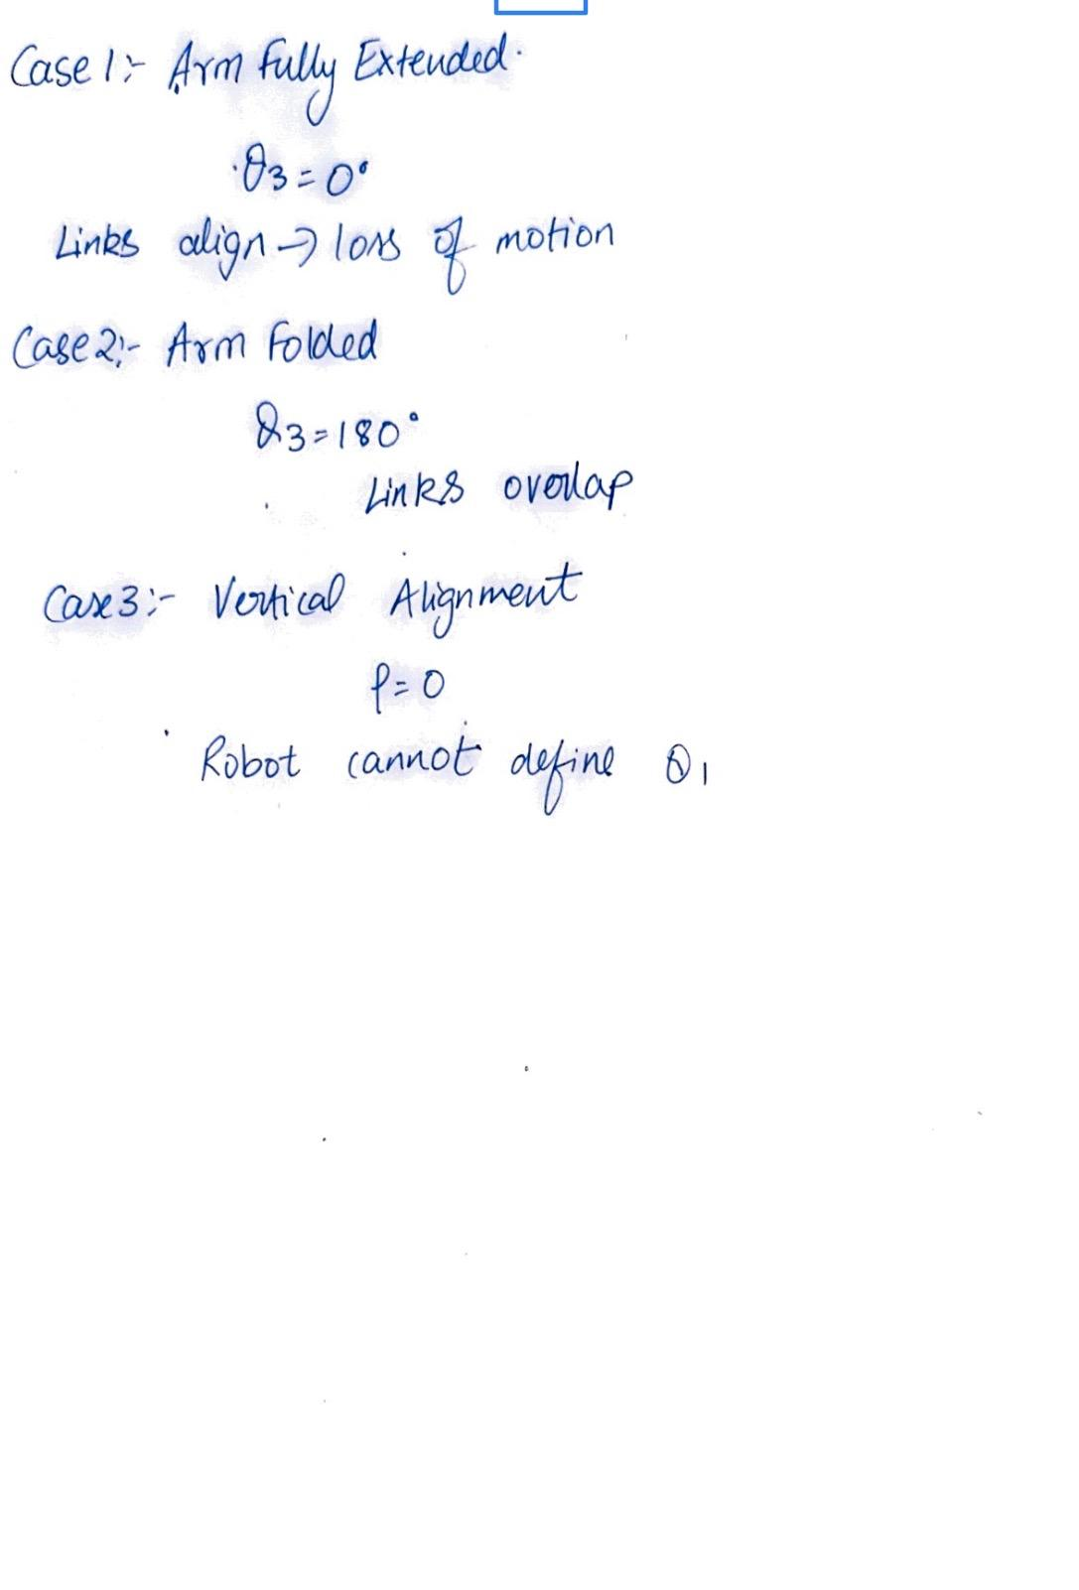
2.3 Workspace and Trajectory Planning

Experimental testing of workspace limits to prevent unreachable points and singularities.
Trajectory planning involved:
Pushing the z-coordinate while transitioning to prevent collisions
Update z only while grabbing and releasing
This includes ensuring smooth movement between pick and place points

2.4 Dynamic Considerations
A 0.5-second delay was added after each movement to allow the robot to stabilize. This was necessary because, during early tests, “the gripper would release the block while moving” due to insufficient settling time .

  - Comparison

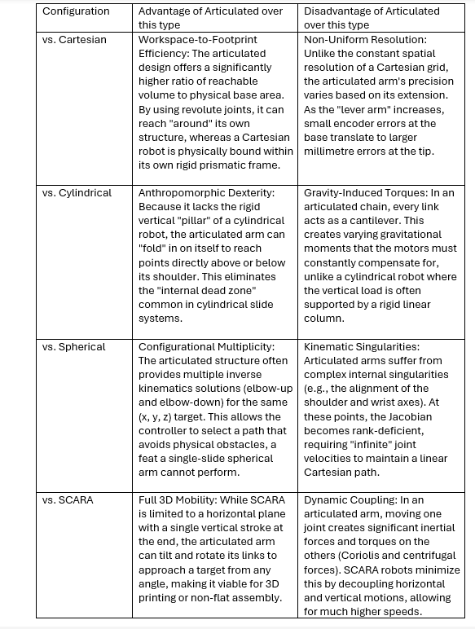

3.Results
Using only the pre–defined coordinates, the robot successfully stacked them. The end-effector was reliably placed at each target location by the inverse kinematics solver, and additional delays facilitated stable gripping and releasing.
Eventually adjusted the z-coordinate such that it did not collide with previously stacked blocks, and ensured the robot stayed within its safe workspace during operation.

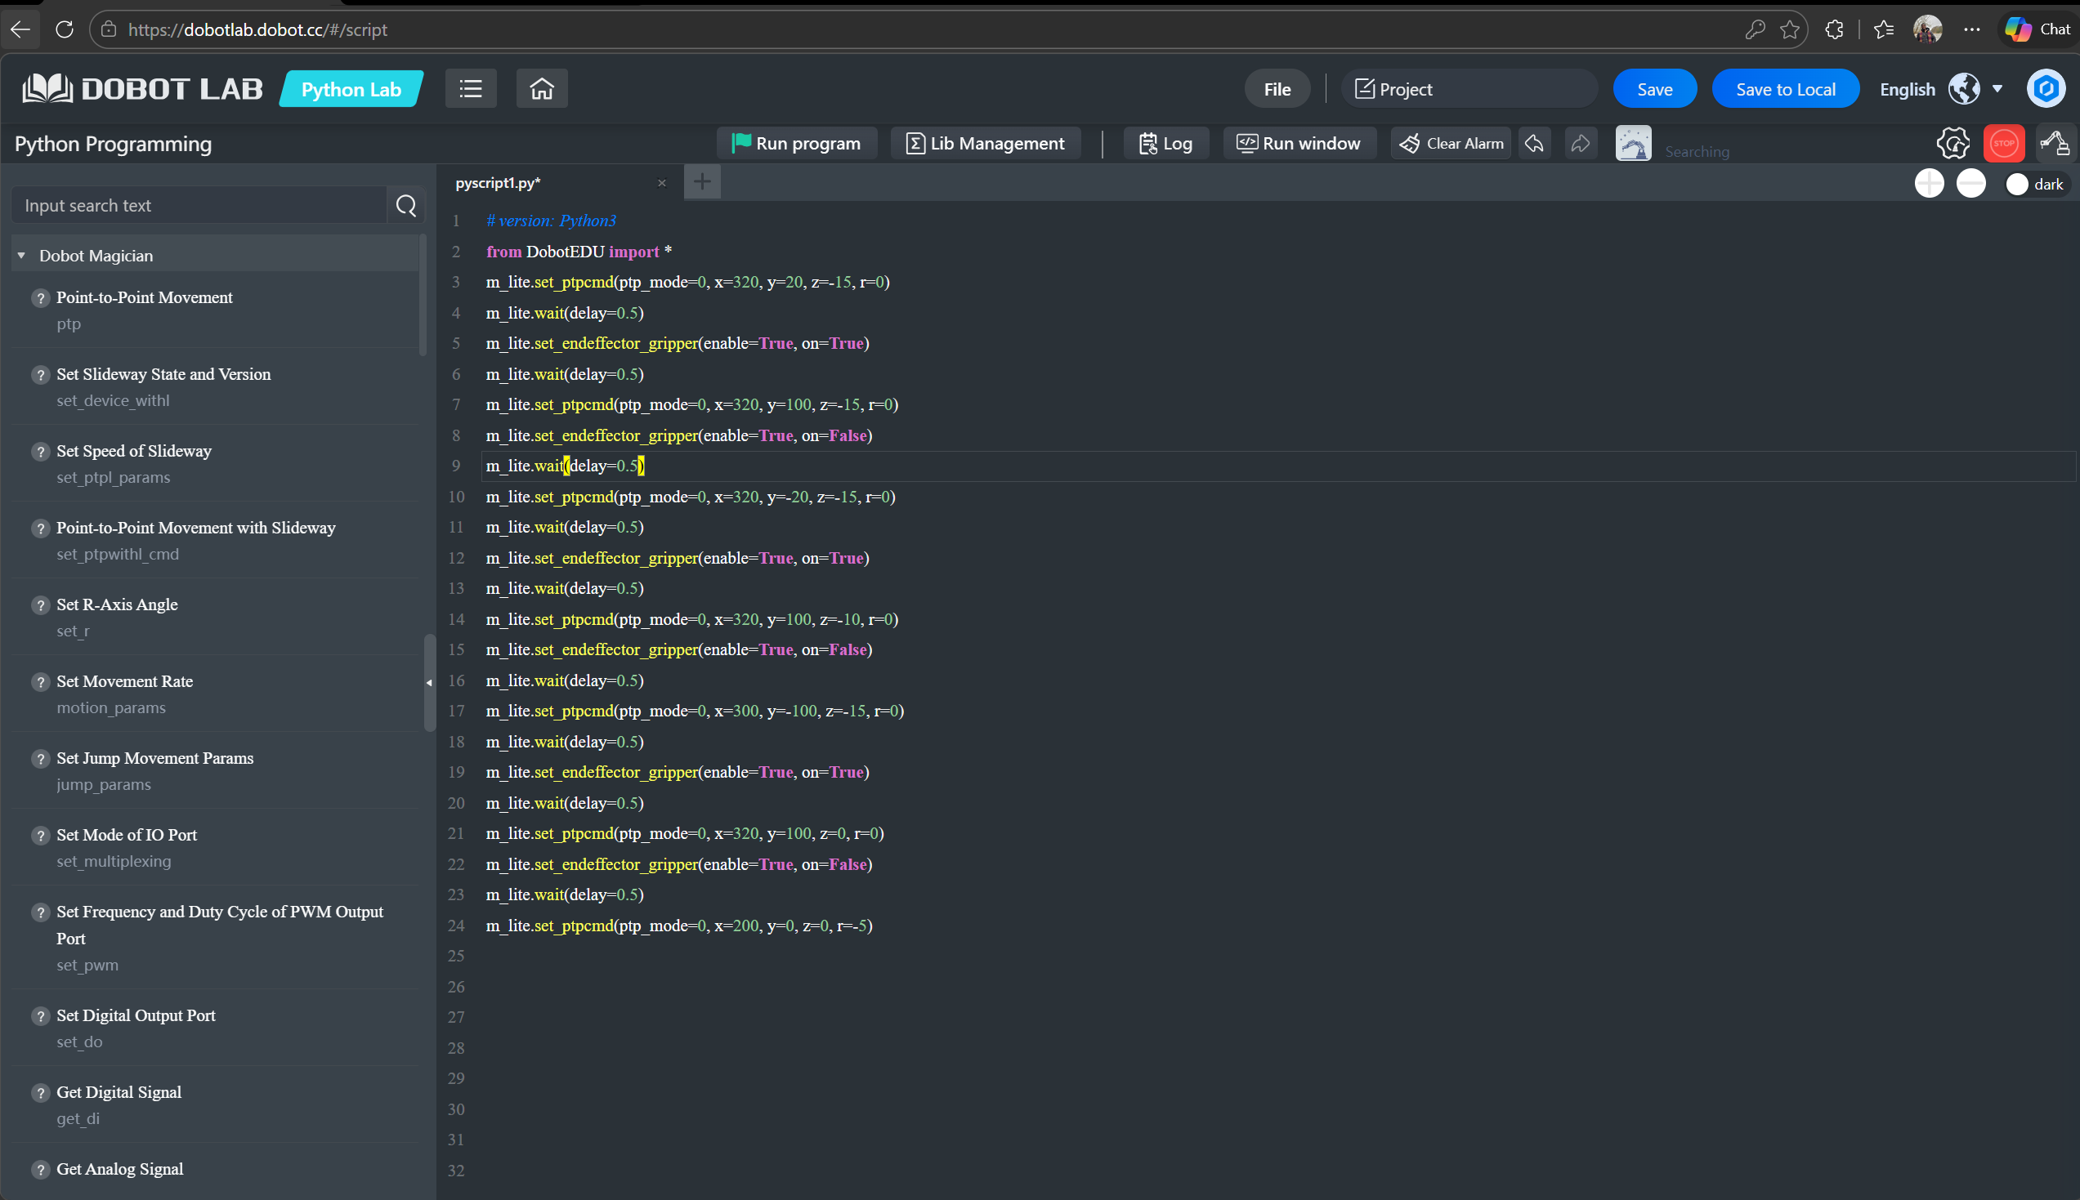

4.Discussion

The experiment showed that simple pick-and-place tasks can be performed robustly through open-loop Cartesian control. However, the approach has limitations:
Not scalable: The sequence depended on “hardcoded coordinates instead of sensor feedback”.
No flexibility: If you shift blocks or misalign them, the robot can’t adapt.
Do not know if they are in motion: The absence of perception means that the robot has no idea if it is moving over a surface, nor does it understand what this surface is.
A more advanced system would essentially combine computer vision with this encouragement of object positions to dynamically assess where the objects are in real-time, according to the report.

5.Conclusion
The task was a simple 3 block stacking using Cartesian defined targets and built in inverse kinematics on the Magician Lite robot arm. Workspace Analysis, Dynamics, and Kinematics- This project reinforced these key concepts. Although effective for highly controlled experimental settings, the standard approach of supervised learning does not generalize well to real-world diversity. Thus, the direction of future work should tie together vision-based perception with closed−loop control to make adaptive and scalable automation possible.

